Muhammad Arham
L1F23BSSE0372
CP
Good Code
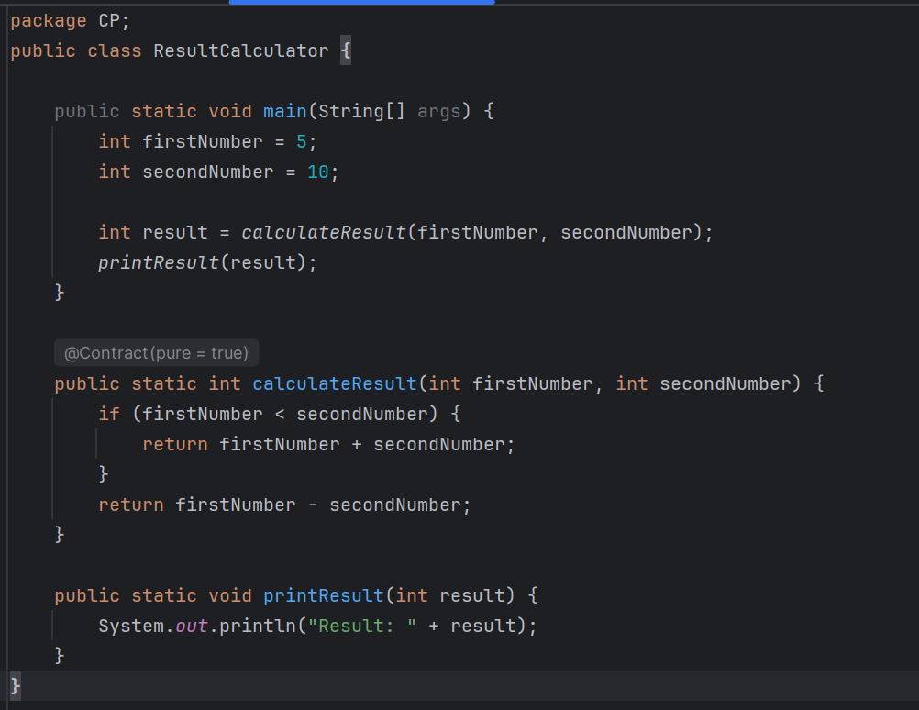
Bad Code
